The 2013 Computing Challenge

Introduction
Alan Mathison Turing (1912-1954) was an outstanding British mathematician whose pioneering work underpins much of contemporary computer science and artificial intelligence.
His notable contributions include:
- Formulation of the mathematical foundations of computing;
- Design of machines to crack German military codes at Bletchley Park during World War II;
- Design of the ACE, one of the first digital computers, at the National Physical Laboratory;
- characterisation of the Turing test for establishing whether or not a computer system demonstrates human-like intelligence;
- Exploration of morphogenetic change in biological development.

Several international events were held across many institutions to mark his one hundredth anniversary of his birth in the past year, 2012.

In this challenge, you are invited to explore the Turing machine, Turing’s model of computing which enabled him to establish fundamental limitations to what computers can and can’t do.

The Turing Machine

A Turing machine is astonishingly simple and is based on the idea of a human solving an arithmetic problem using sheets of paper and a pencil. Essentially, starting with a blank page, a person writes down numbers and formulae, looks back at what they’ve written already, rubs things out and replaces them with new things. When they fill a page they move onto a new one.

By analogy, a Turing machine has a linear tape, composed of cells. Each cell can be blank or can hold a symbol like a letter of the alphabet. The tape head can read from and write to the current cell. The head can also move left or right over the tape, a cell at a time. We can view the tape as being the memory of a Turing machine.

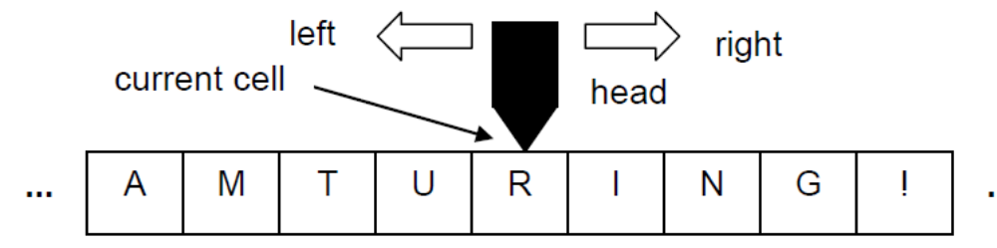

When a human is solving problems using paper and pencil, the rules they follow are in their head. In contrast, the rules for a Turing machine must be made explicit. To explore these rules, let’s consider the problem of making a negative copy from a black and white image, where all the black pixels are changed to white and all the white pixels are changed to black:

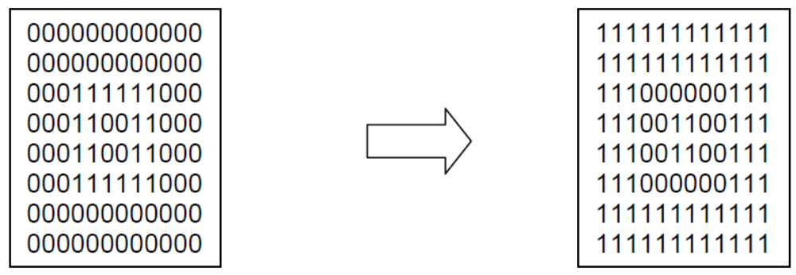

Suppose we lay the image out along the tape, tow by row, with successive pixels in successive cells. We start the image with a “*” and end it with a “*”. And we start with the tape head over the left most “*”. For example, given:

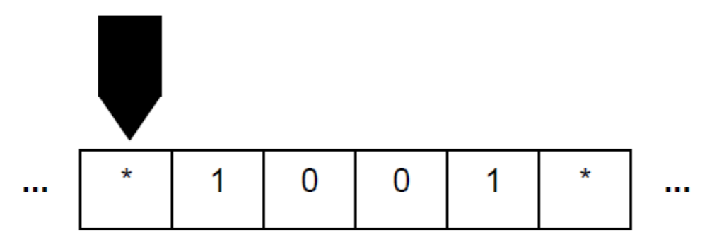
we want to end up with:

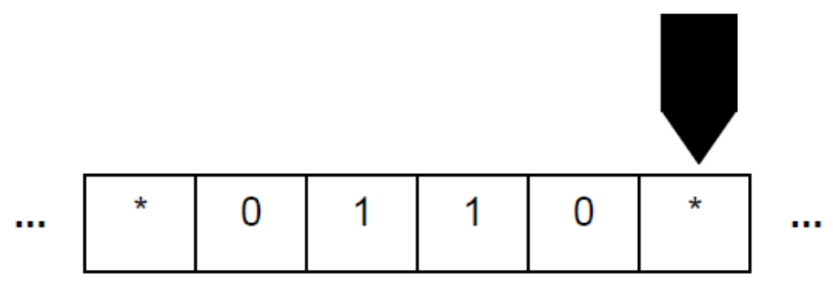

Every time the head is over a cell with a “0” it changes to a “1” and when it’s over a cell with a “1” it changes to a “0”. We stop when we find a “*”. Our rules, or instructions, then say:

START: if the head is over a “*”, write a “*”, move head right and INVERT

INVERT: if the head is over a “0”, write a “1”, move head right and INVERT
INVERT: if the head is over a “1”, write a “0”, move head right and INVERT
INVERT: if the head is over a “*”, write a “*”, halt the head and STOP

STOP: do nothing

We have grouped sets of instructions associated with a specific task together and given them names in italics: START, INVERT, STOP. We call these groups of instructions the states of the Turing machine.

At any point in the processing, the Turing machine is said to be in the current state which determines which group of instructions should be considered. In the current state, with a given symbol under the head, we look for a matching instruction and act accordingly.

For our example, the processing sequence is:

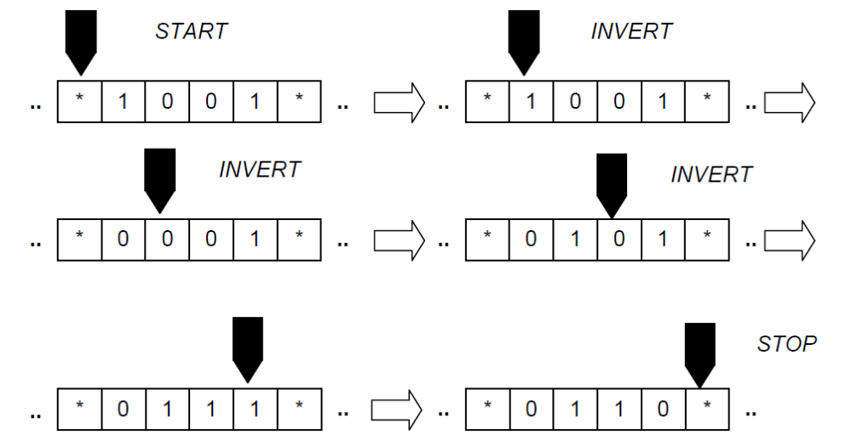
When a problem solving human fills the current piece of paper, they can start on a fresh sheet. In the same way, if the Turing machine finds itself at either end of the tape, then a new empty cell is added. Thus, although at any given moment the tape is finite in length, in principle it can grow arbitrarily long!

Let’s now consider copying a sequence of “1”s between “*” to the right of the rightmost “*”. Starting with:

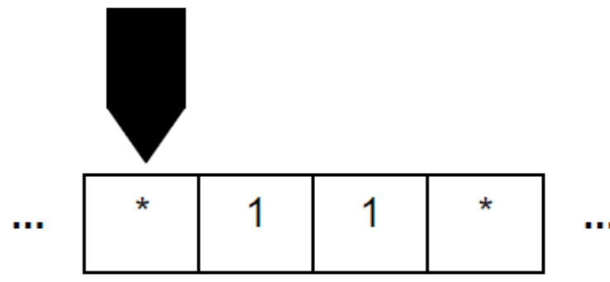
we want to end up with:
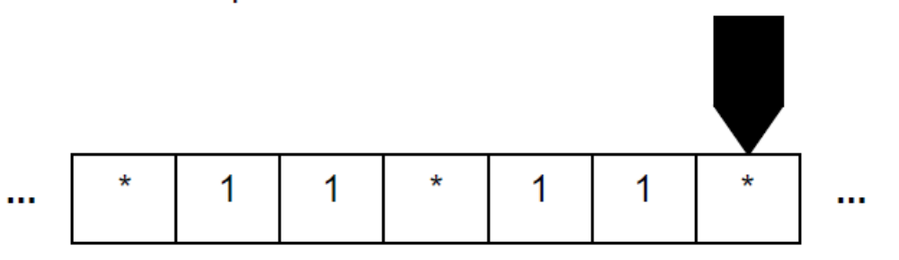
We start over the leftmost “*” moving right looking for a “1”. When we find a “1”, we will change it to an “A” so we don’t copy it again. We will then move right and write a “1” in the first empty cell. This involves reading and writing intermediate “1”s and “*”s. We then move left to the “A”, change it back to a “1”, and move right looking for the next “1”. If we find a “*” instead then we have copied all the “1”s so we move right to the first empty cell, write a “*” and stop.

Our instructions are now:

START: if the head is over a “*”, write a “*”, move right and FIND1

FIND1: if the head is over a “1”, write a “A”, move right and COPY
FIND1: if the head is over a “*”, write a “*”, move right and END

COPY: if the head is over a “1”, write a “1”, move right and COPY
COPY: if the head is over a “*”, write a “*”, move right and COPY
COPY: if the head is over a blank, write a “1”, move left and NEXT

NEXT: if the head is over a “1”, write a “1”, move left and NEXT
NEXT: if the head is over a “*”, write a “*”, move left and NEXT
NEXT: if the head is over a “A”, write a “1”, move right and FIND1

END: if the head is over a “1”, write a “1”, move right and END
END: if the head is over a blank, write a “*”, don’t move and STOP

STOP: do nothing

So, the processing sequence, missing out intermediate steps where the current cell and state are unchanged, is:

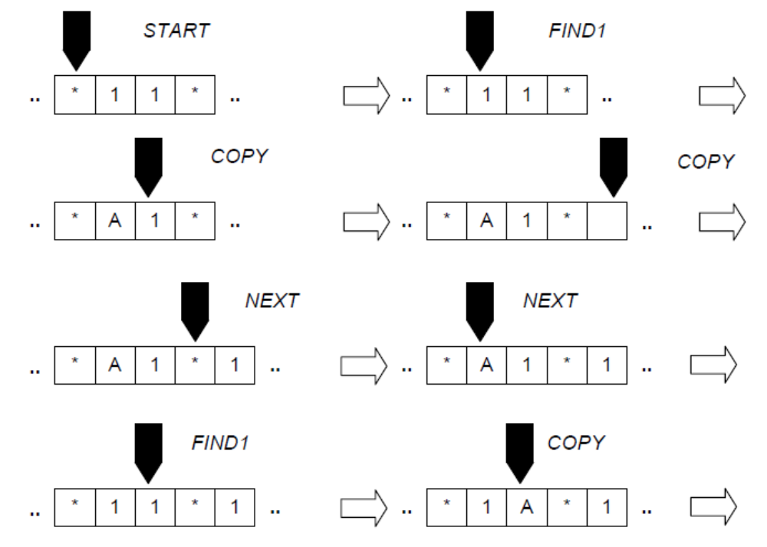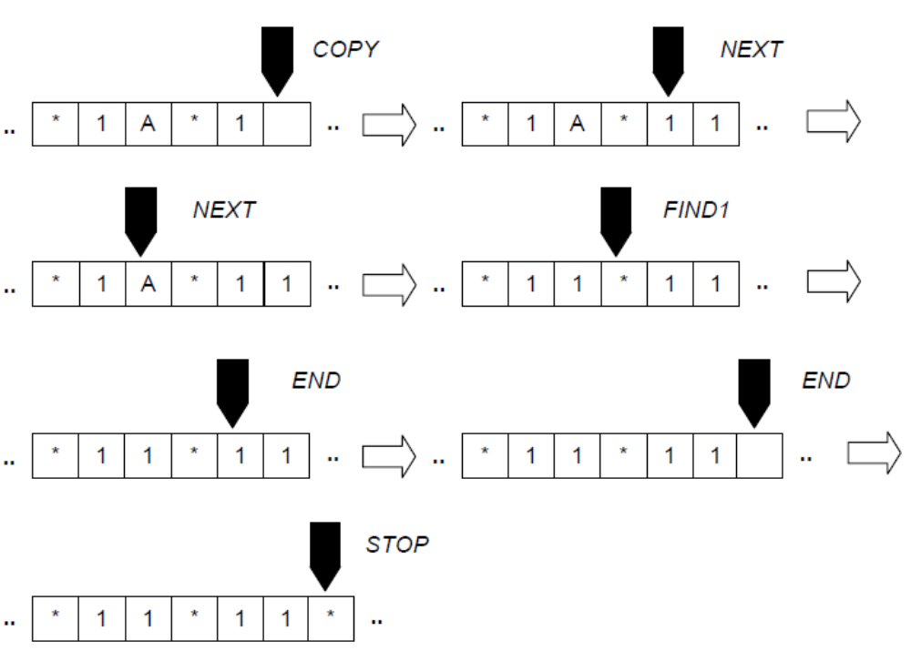

Turing Machine Notation and diagrams
Conventionally, Turing machine instructions are written as quintuplets in the form:

(old state, old symbol, new state, new symbol, direction)

So the behaviour of a Turing machine is :

WHILE not halted
IF the current state is the old state and
the head is over the old symbol
THEN
- the current state becomes the new state
- the symbol under the head changes to the new symbol
- the head moves in the direction.

A machine halts when it encounters a halt direction or there is no quintuplet corresponding to the current state and symbol under the tape head.

We will write _ for a blank cell, L for left, R for right and H for halt, and we will not write details for a STOP instruction. Our first example is:

(START,*,INVERT,*,R)

(INVERT,0,INVERT,1,R)
(INVERT,1,INVERT,0,R)
(INVERT,*,STOP,*,H)

Our second example is:

(START,*,FIND1,*,R)

(FIND1,1,COPY,A,R)
(FIND1,*,END,*,R)

(COPY,1,COPY,1,R)
(COPY,*,COPY,*,R)
(COPY,_,NEXT,1,L)

(NEXT,1,NEXT,1,L)
(NEXT,*,NEXT,*,L)
(NEXT,A,FIND1,1,R)

(END,1,ND,1,R)
(END,*,END,*,R)
(END,_,STOP,*,H)

Quintuplets are said to characterise state transitions, that is changes between states.
It is also conventional to portray Turing machines as state transition diagrams where:
• each state is a labelled circle;
• each transition is a directed arc from a state to a state, labelled with the old symbol, new symbol and direction.

For example, we might diagram the copying machine as:
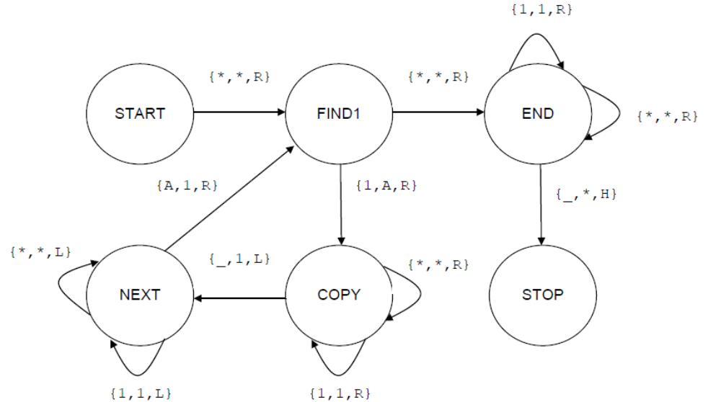

The challenge
The Programming Challenge is to write a Turing machine simulator which can:
- input a set of quintuplets and an initial tape from a file;
- run the Turing machine on the tape until it halts.

An input file is formatted with:
- an initial count of the number of quintuplets;
- each quintuplet on a separate line, in the above format, where:
  - an old or new state is an integer and the start state is 0;
  - a symbol is a single character;
  - a direction is L, R or H;

- the tape as a continuous sequence of characters between ! and !, including spaces but ignoring line breaks. The initial tape cell is indicated by a character within < and >.

Test “tape files” will be provided.

The simulator should be run within a graphical user interface (GUI) which at least enables:
- selecting and loading the input file;
- running the simulation:
  - continuously;
  - step by step.

To begin with, the Turing machine is:
- in the start state 0;
- with the head over the initial tape cell.

At each step, the simulation should display at least:
- the current state;
- the cell under the head;
- a small number of cells on either side of the head;
- the successful quintuplet.

Further, especially for group submission, enhancements would be to:
- enable the setting of an initial blank tape by the user, where individual cells may be selected and modified;
- generate the state transition diagram;
- animate the state transition diagram during simulation.

